VPC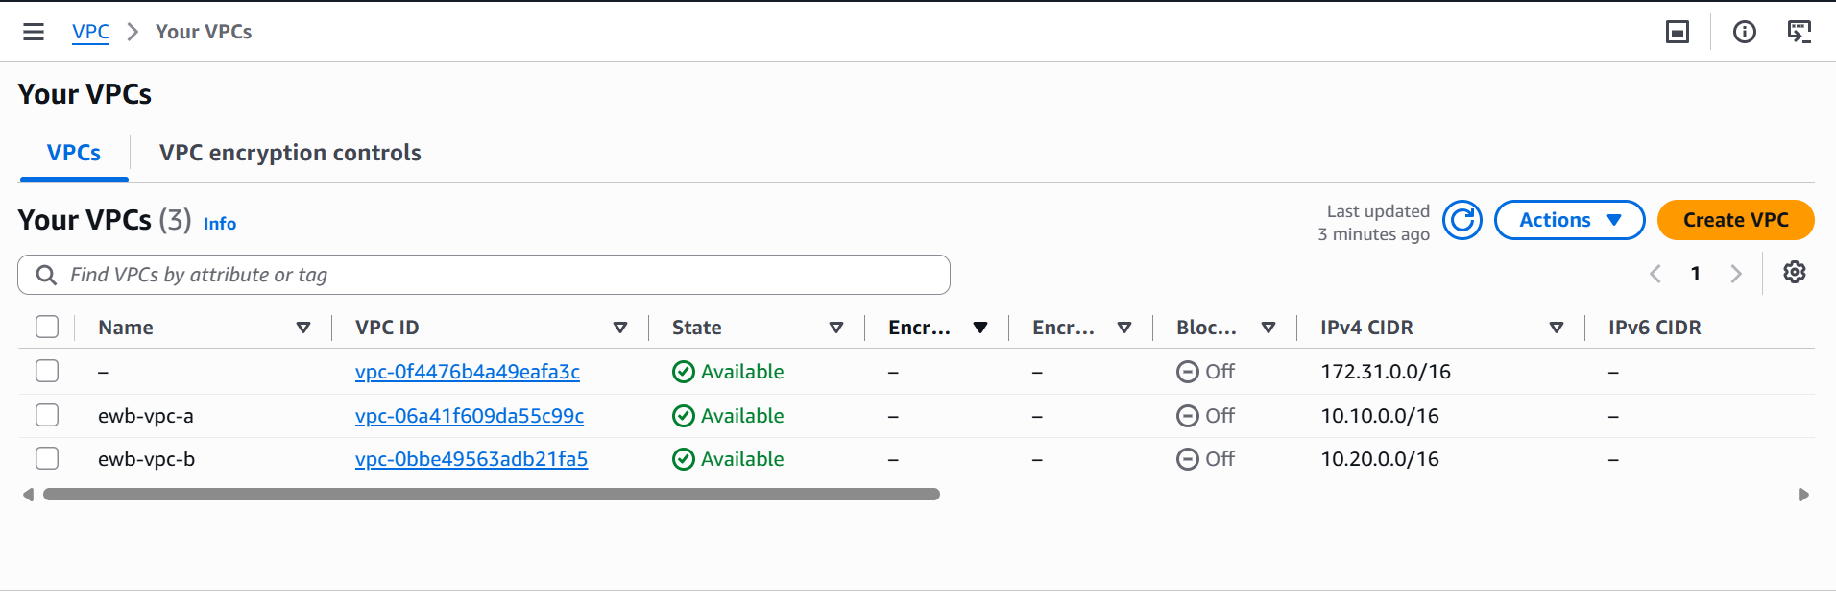

Subnets
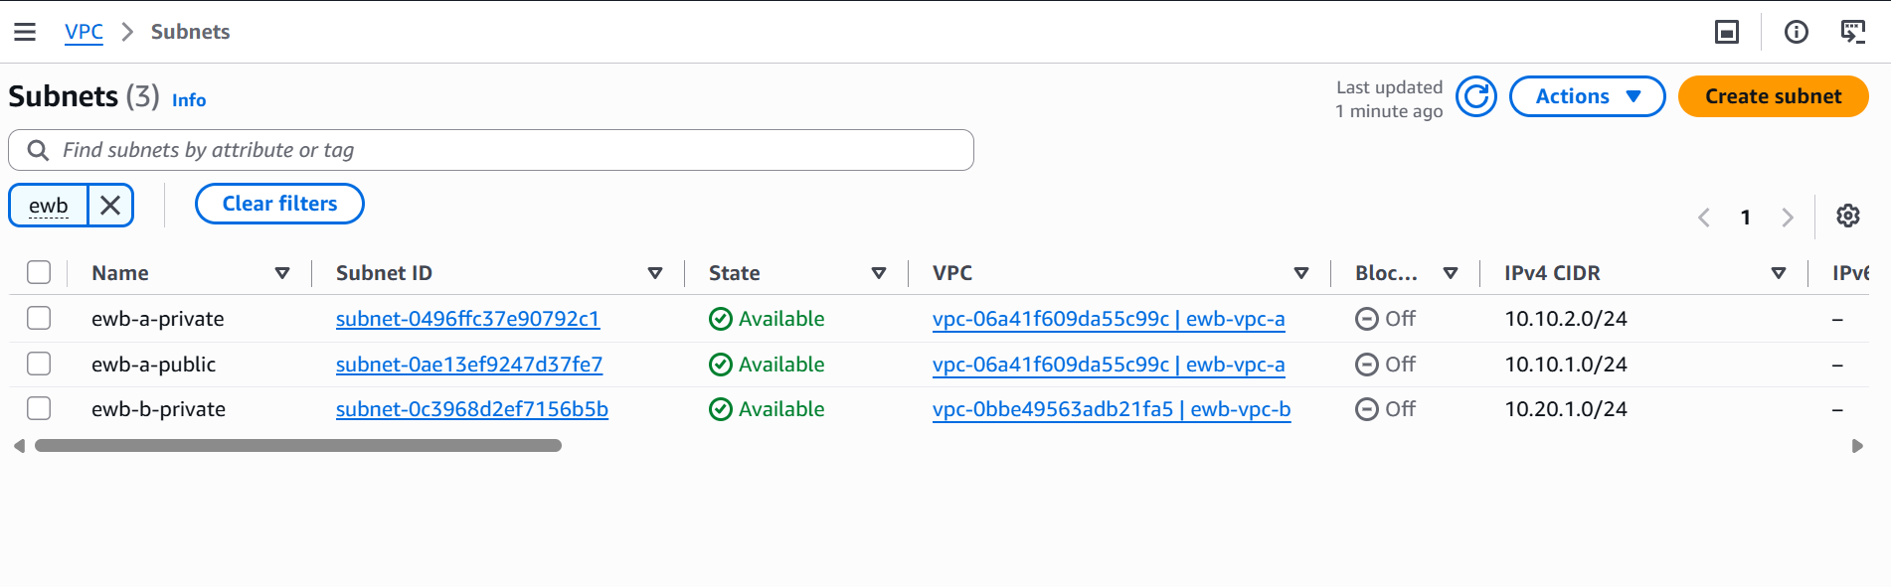

Internet Gateway
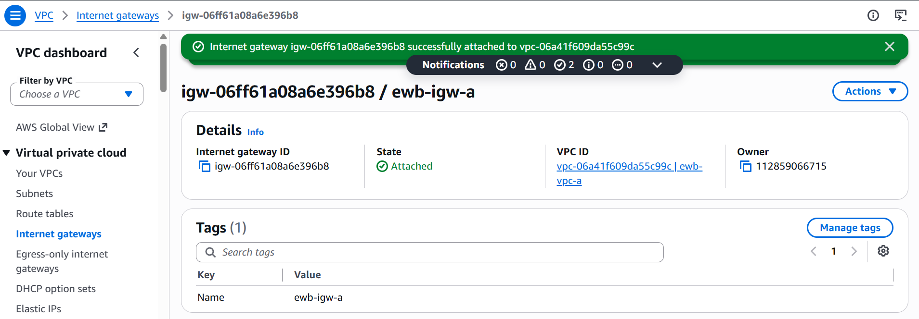
Route tables with subnet Association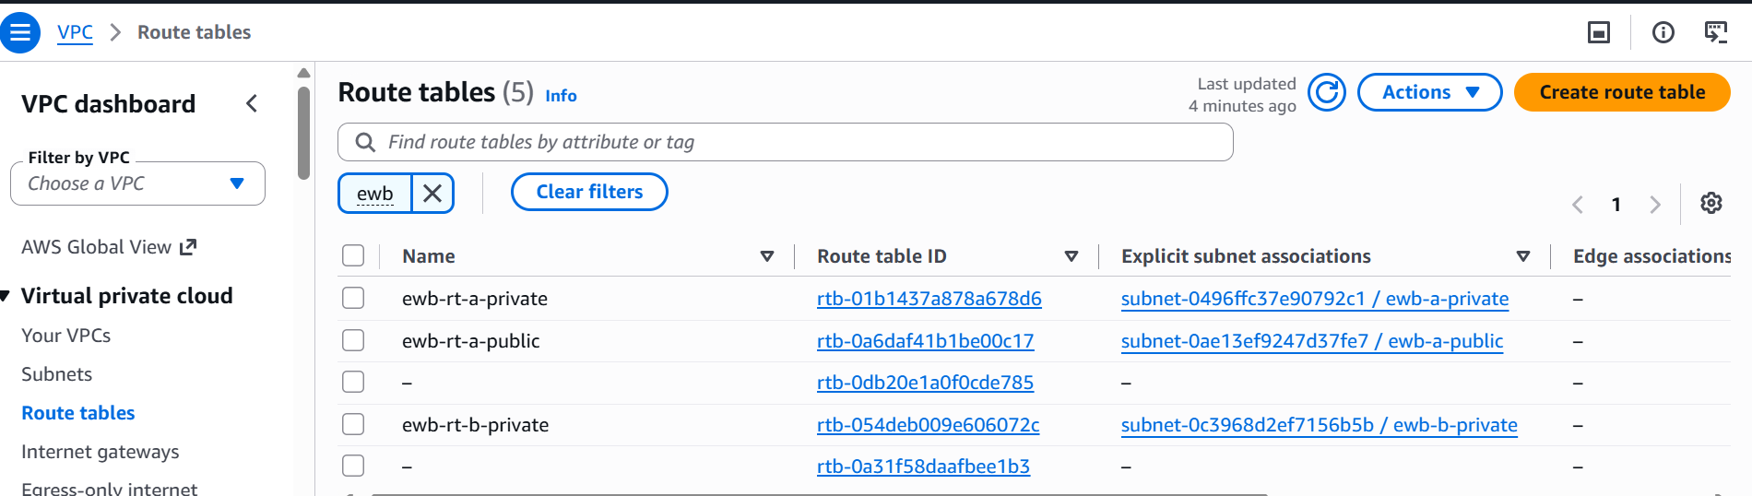

Route Table –Vpc A public
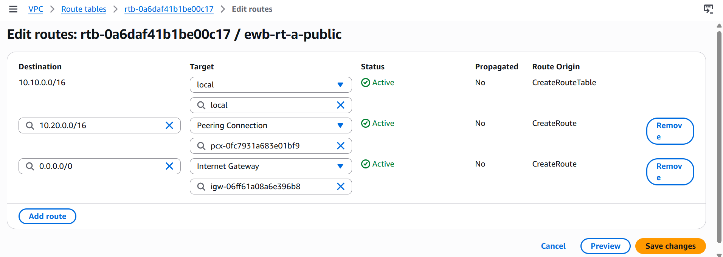

Route table – Vpc A private
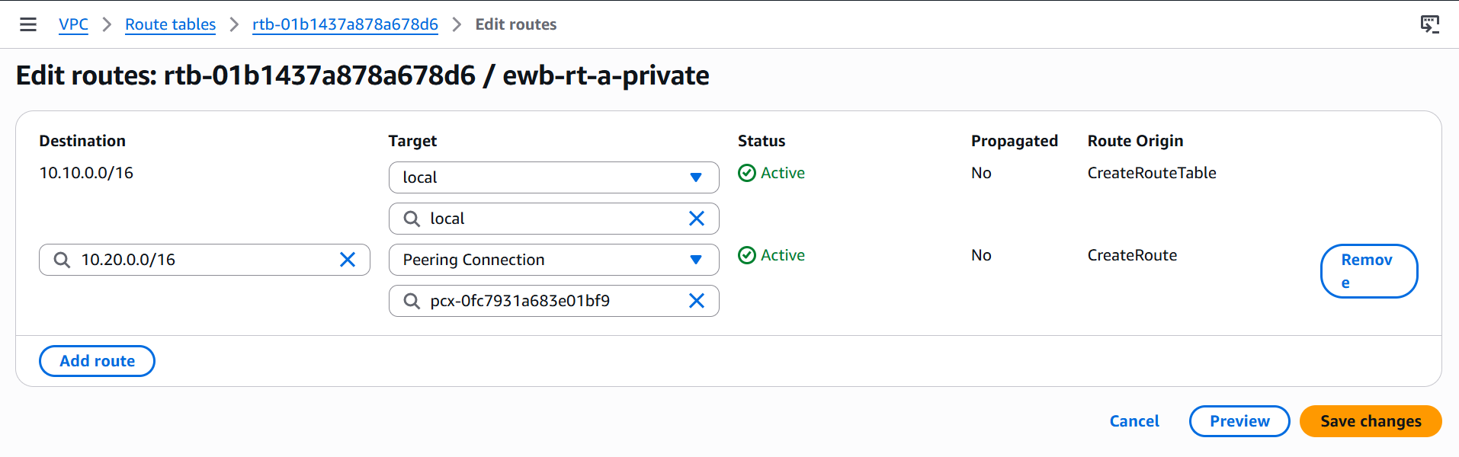

Route Table – Vpc B private
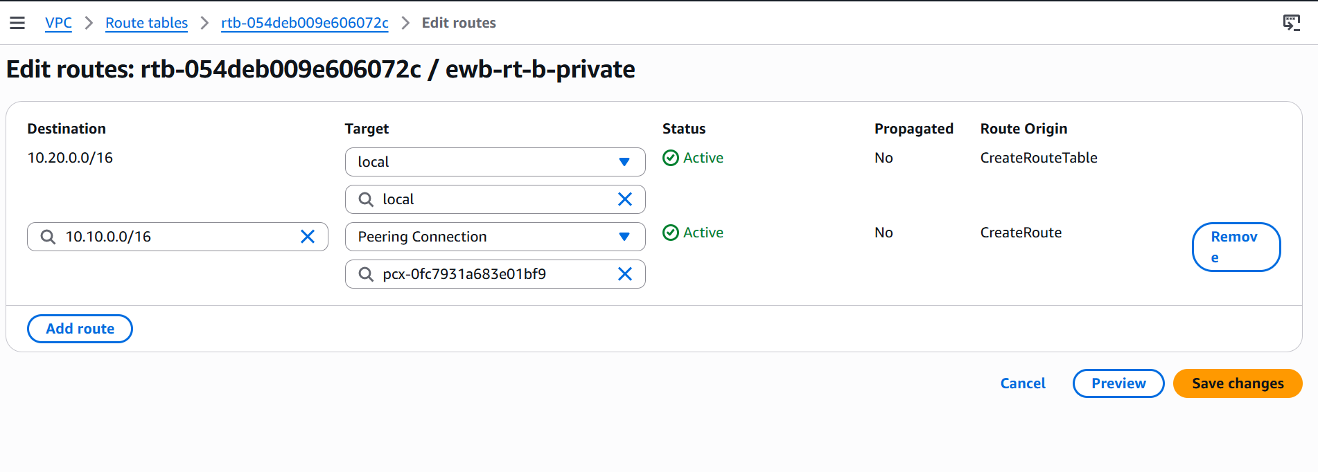
Security Group
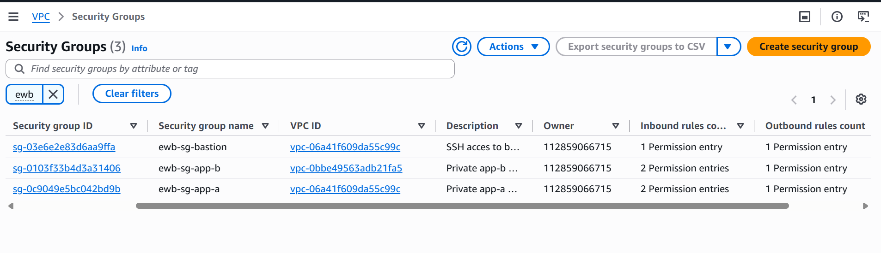

Key pair
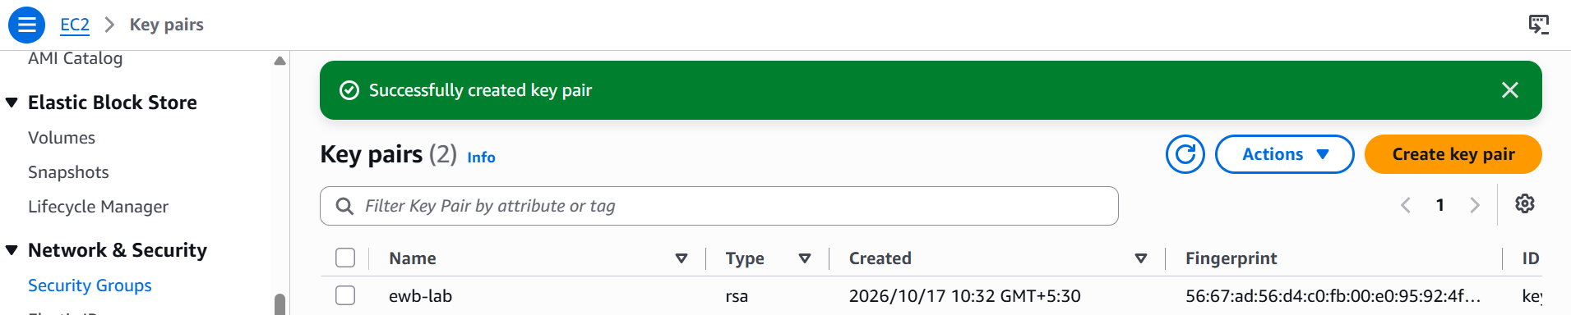

EC2 Instances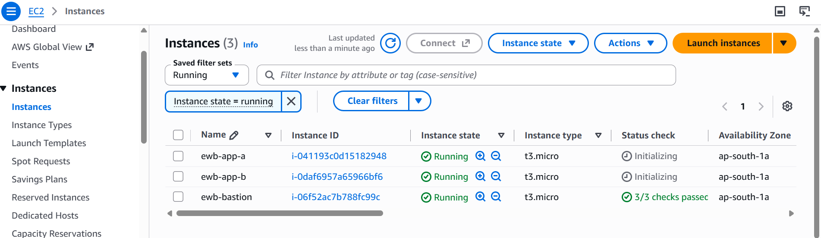

Peering Connection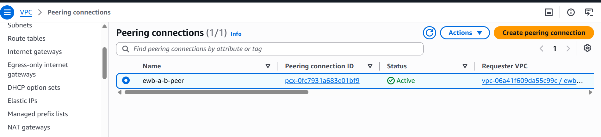

Base Test case
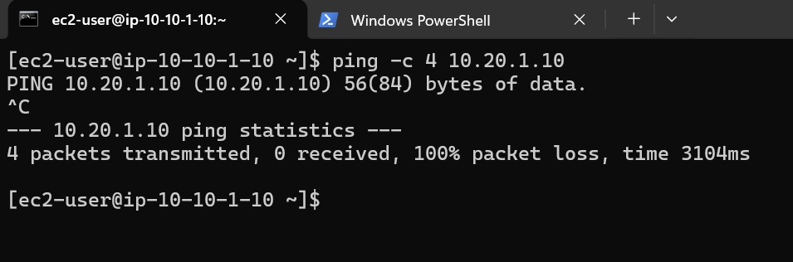

Bastion to app b
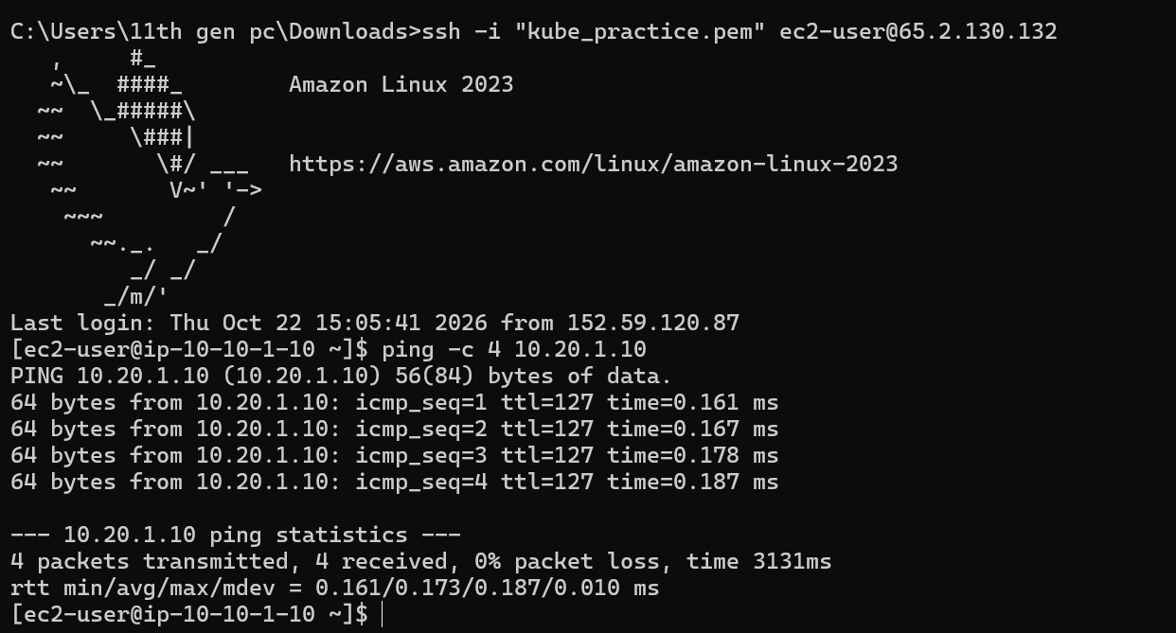

Ping status from A to B
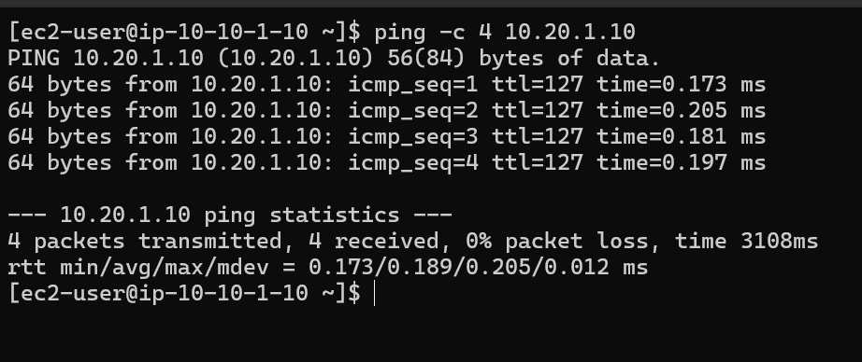

Ping status from B to A

